**SOFTWARE MANUEL**

**PEREZ CHURCH SOFTWARE**

**VER. 1**

Technical Specifications

The system is developed using Php and runs on Apache webserver. PHP version 5.4 which is the minimum version requires to run the app. The server must be configuring to enable the following

1. Fopen
2. File get content
3. File upload of size of 40MB

Installation

Follow the following steps to install copy of this software

1. Download xampp (php version 5.6 upwards) - xampp-win32-5.6.23-0-VC11-installer
2. Install xampp
3. Extract the perez.zip into the Htdocs folder of the xampp installation folder
4. Open the xampp installation and click on the start apache(webserver) and start mysql (database)

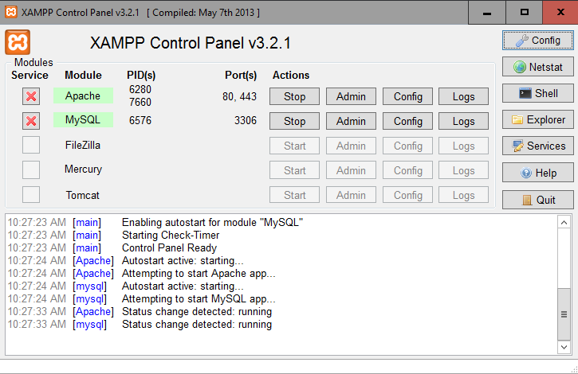

1. Open your browser and goto localhost/phpmyadmin
2. Create database with name db_perez_chapel
3. Click on import and select the sql file in the htdocs folder ie db_perez_chapel.sql
4. Click on go and this upload your database

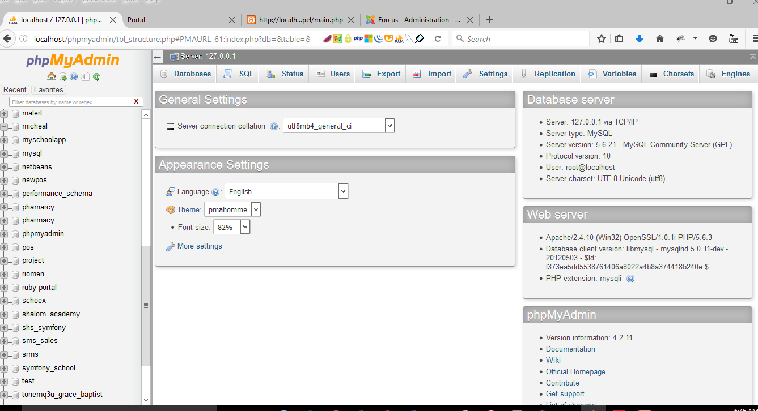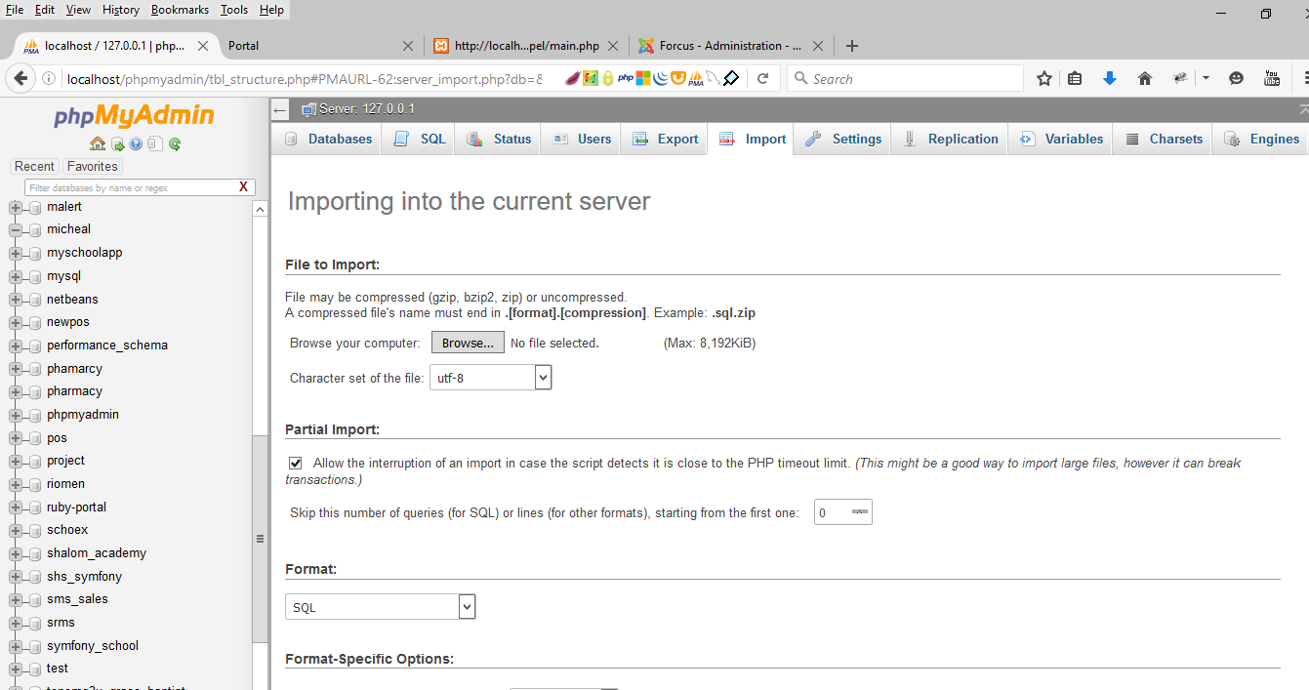

1. Now goto your browser again and type localhost/perez_chapel or whatever name of your folder in the C:\xampp\htdocs\
2. Login with trial admin account username 1 and password 1

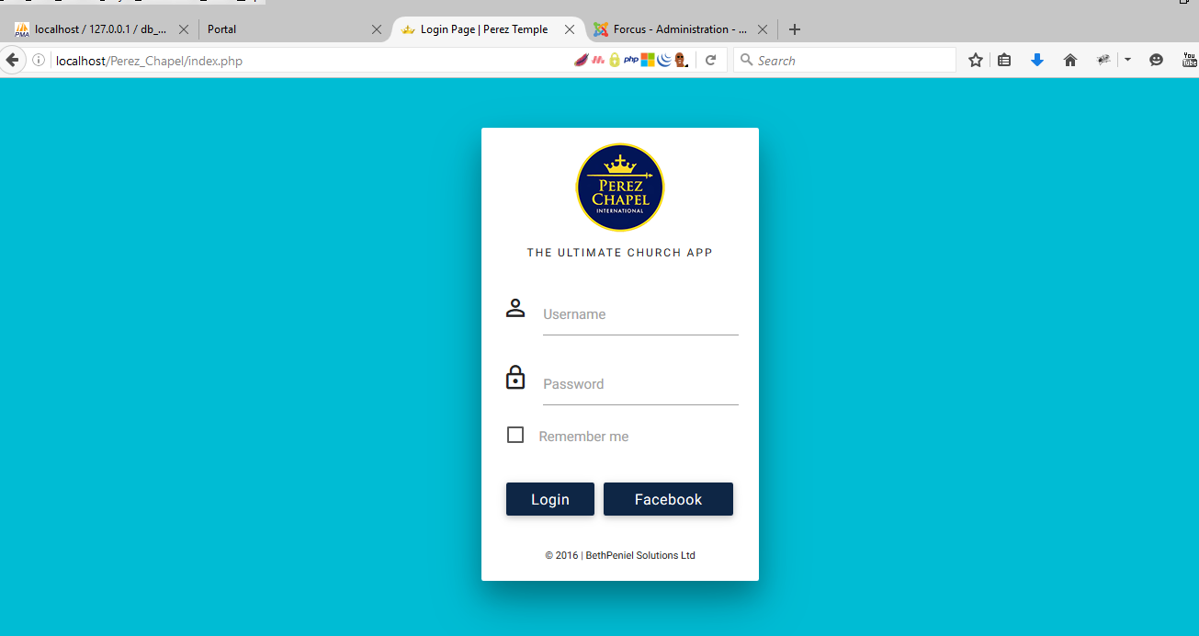

Good you have install perez chapel soft ver. 1

**Modules of Perez App**

The software is made up of the following modules and these modules further have access permissions

1. Setup Module (head pastor, assistant pastors and Elders permission can access this)
2. Membership module (All access with different access levels eg only pastors and Elders can send schedule sms and emails)
3. Branch Management (Pastors can create circuits, districts and branches that members can belong to. If the church runs other branches as well)
4. Group Management
5. Fund and Finance Management (Pastors and Accountants)
6. Service Management and Scheduling (Pastors and other members like church administrators)
7. Asset Module
8. Systems and users (backup database , create users , logout )

**Full Access of the App**

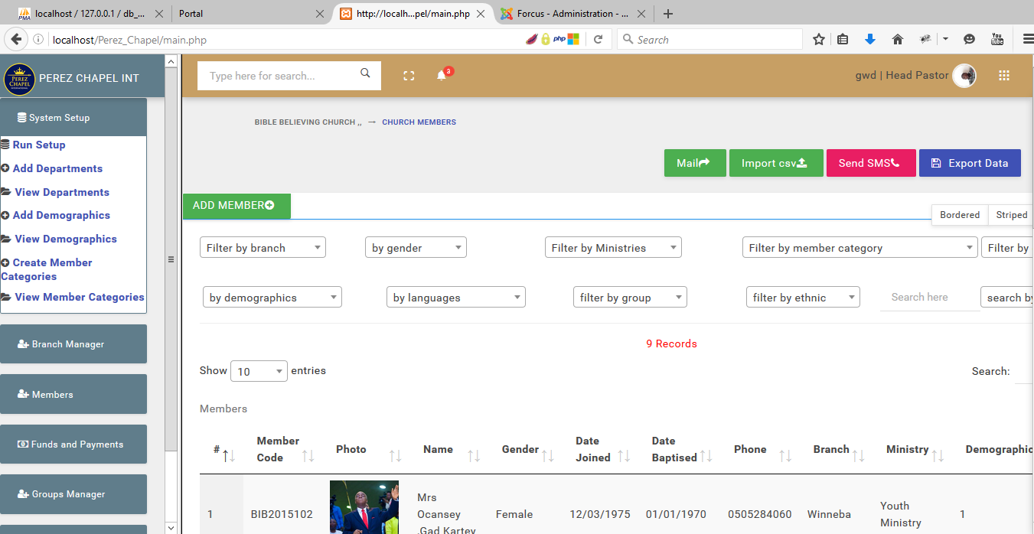

**Running the setup menu**

The setup menu which is the first menu on the left sidebar provides the following infos

1. Basic information about the church
2. Create departments and demographics
3. Member categories

NB: Please run the setup first. Is necessary before proceeding

**Membership Module**

The membership module consists of the following

1. Add Church Members data
2. Adding Visitors Data
3. Follow ups
4. Children information
5. Family information

**How to add member data into the system**

1. Click on members on the left menu
2. Click on add member
3. Fill the necessary or required information
4. Click on save

**How to generate reports on members**

1. Firstly click members menu on left sidebar of the app
2. Select the membership type you want to generate the report from eg. Members, visitors
3. Reports can be generated by applying a filter from the drop down menus on top of the members page. Eg all members who are in a particular branch. You have to choose the branch from the drop down.

**How to export members’ data to excel**

1. Goto the view members under membership menu
2. Filter the reports you want. Eg all males in the church
3. Click on the export button located at the top right corner of the page

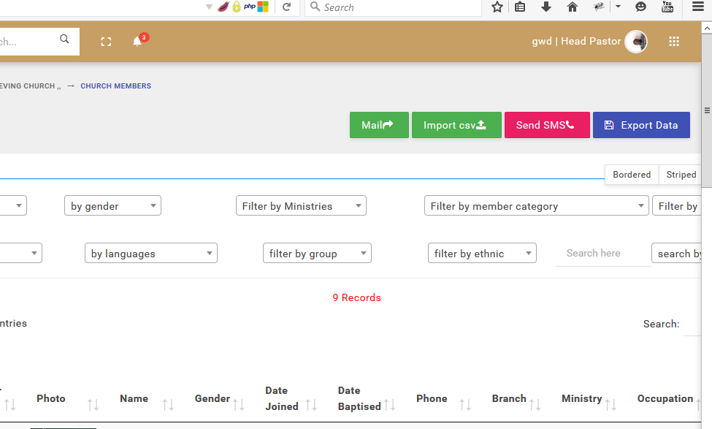

**To send sms to members**

1. Goto the view members under membership menu
2. Filter the reports you want. Eg all males in the church
3. Click on the send sms button located at the top right corner of the page and type your message in the pop up box.
4. Click send button to send the sms

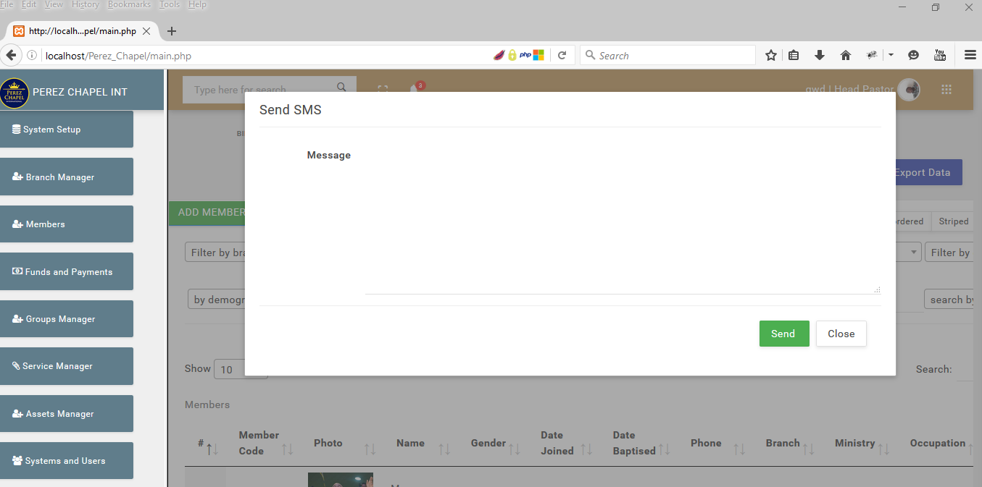

**Importing bulk members**

1. First use the template file located in the upload folder
2. Fill in all the necessary columns and save it in .csv(comma delimited)
3. Goto members’ menu on the left side bar
4. Click on the import csv button on the top right corner
5. upload the csv

